MISSION STATEMENT  Guadalupe Discernment House supports men in vocation discernment by providing a prayerful Catholic community where the Holy Spirit can make God’s Will clear.  Please help by praying the following prayer:  Almighty God, You  have made us to know You, to love  You, and to serve You, and thereby to  find fulfillment.  You are in all things  and every path can lead to You, but of them all, there is one path especially  by which You want each person to come to You.  Send Your Holy Spirit to those discerning, so that they find that path and follow it right to the end.  Amen. |  | Guadalupe House Renovations Fund  1702 Lumbard Street  Fort Wayne IN 46803 | Guadalupe House Renovation Fund  c/o Confraternity of Penitents  1702 Lumbard Street  Fort Wayne IN 46803 |  | 24 room, 90 year-old former convent for sale in Fort Wayne, IN  - 8 Bedrooms  - 3 ½ Baths  - 1 Kitchen  - 2 Kitchenettes  - Chapel  - Parlor  - Dining room  - Office  - Laundry and work rooms  - Air conditioned, gas heat  - Price: $10,000  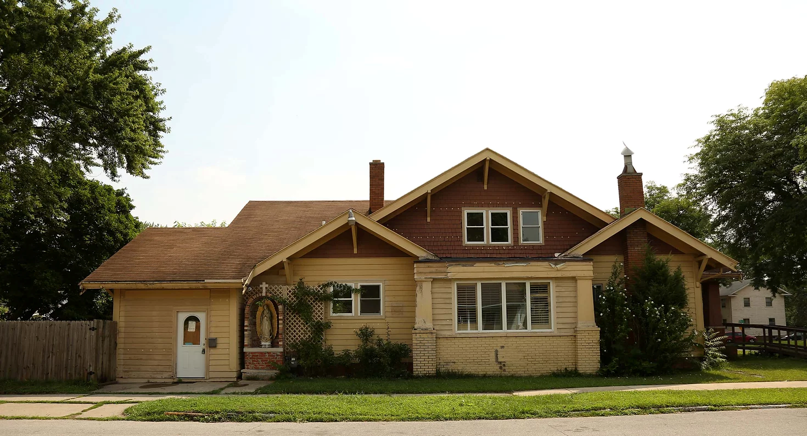
What’s the catch?  The $10,000 was just the cost of clean-up from extensive interior water damage from a burst pipe in the second-floor bathroom.  The good news is, we’ve paid the price! The house has been purchased and is being transformed into Guadalupe Men’s Discernment House.  www.GuadalupeVDH.com  Guadalupe Discernment House will:  - House up to eight men from anywhere in the USA and provide support in a peaceful environment.  - Be available to men for overnight stays and private retreats.  - Resurrect the Community Harvest Food Voucher Program for the poor in this vicinity.  - Invite the public into the house Chapel of 1000 priests. The chapel will be blessed not only with icons and a life-sized replica of the tilma of Our Lady of Guadalupe, but also with the names of 1000 sponsored holy priests (living, deceased, and canonized).  We’ve already raised $30,000 of the $180,000 needed, but we need your help! Please consider sponsoring one of your beloved priests!  https://www.1000priests.org |  | 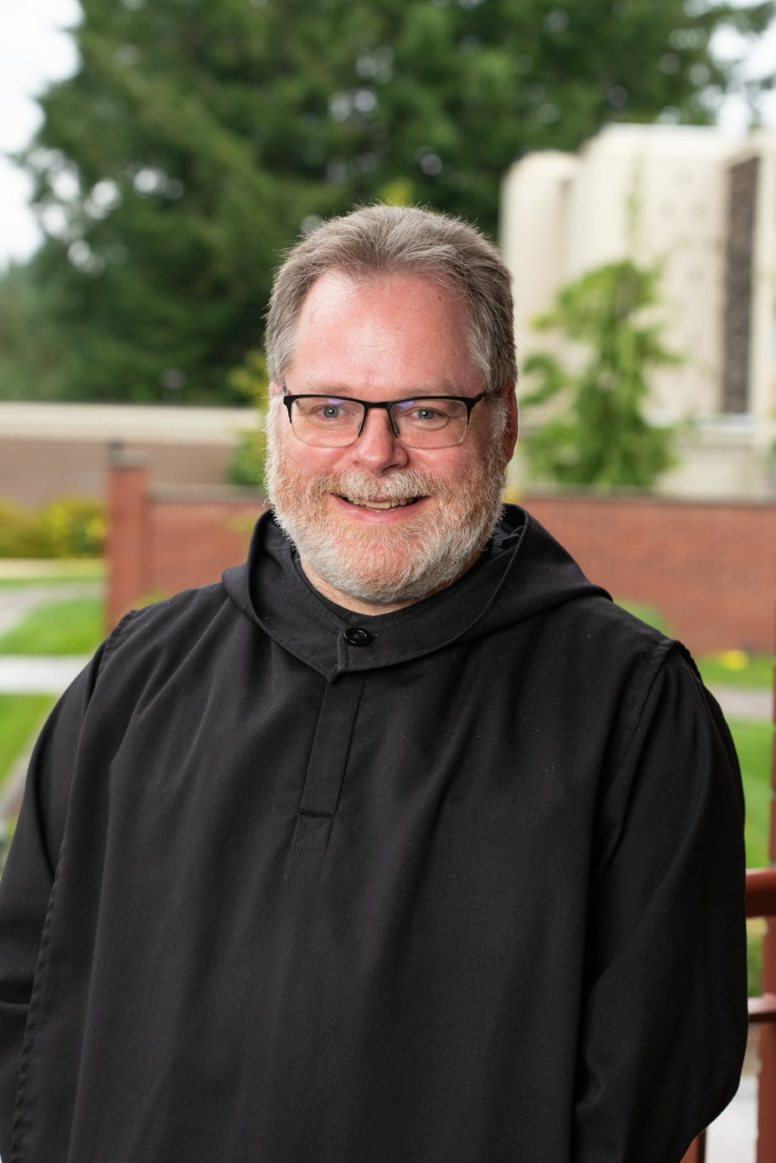  Having spent time [there] while I was discerning my own vocation, I can speak with personal experience to the love and dedication with which they work.  – Br. Pachomius Hamor, OSB  Patrick (now Br. Pachomius) entered the vocation discernment house when we were located in Rhode Island. Since then, twelve additional men have discerned their life’s path with us! |  |  | A Concrete Way to Help  Our parishes pray for vocations. Here is another way to help men discover and pursue their paths to holiness!  Millions of drops of water damaged the house severely. But we can restore this beautiful home, penny by penny. One penny can restore one drop’s damage. Will you please help?  ____ $180 sponsorship for one priest in the chapel. Submit priest’s name, address for acknowledgement  _____ $5000 room sponsorship in honor of (Name)  ____ Donation toward parlor in honor of Br. Peter Maria, FFM  ____ Donation of any amount  Checks made out to CFP Renovations Fund. Fold donation into this flyer, seal ends with tape, add stamp, and mail.  ALL CONTRIBUTIONS TAX DEDUCTIBLE.  Guadalupe House is a ministry of the Confraternity of Penitents: https://www.penitents.org  We pray daily for benefactors and offer one Mass yearly for them on August 22. May God bless you for your prayers and support!

